14.1 Test (6 points are required)

Question from Layer2
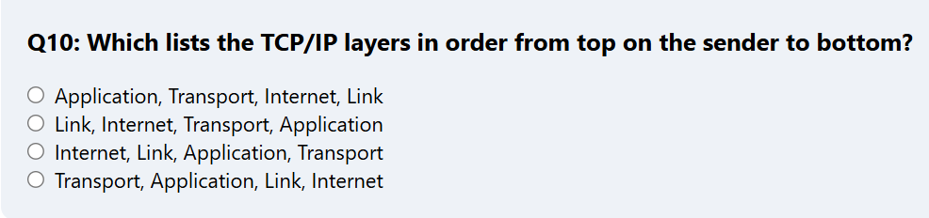[1]

Question from layer3
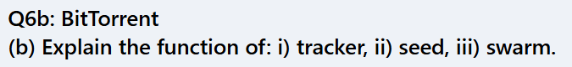
………………………………………………………………………………………………
………………………………………………………………………………………………..
…………………………………………………………………………………………………[3]

Question from layer4
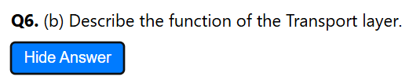
………………………………………………………………………………………………
………………………………………………………………………………………………..
…………………………………………………………………………………………………[3]

14.2 Test (6 points are required)

Question from Layer2
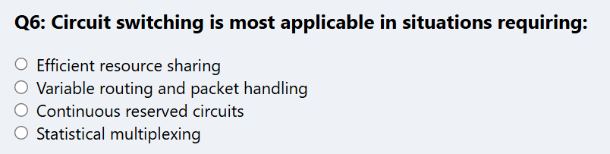[1]

Question from layer3
………………………………………………………………………………………………..
…………………………………………………………………………………………………[2]

Question from layer4
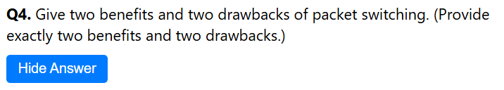
………………………………………………………………………………………………..
…………………………………………………………………………………………………[2]
………………………………………………………………………………………………..
…………………………………………………………………………………………………[2]

